

FURTHER MATHEMATICS
TRIAL EXAMINATION 1
2014
SOLUTIONS

Section A – answers Section B – answers

Core Module 1 Module 2 Module 3 Module 4 Module 5 Module 6
Number Geometry Graphs Business Networks Matrices
Patterns & & related &
Trig Relations Maths Decision

Maths
1. E 1. B 1. D 1. D 1. E 1. E 1. B
2. D 2. E 2. C 2. C 2. B 2. C 2. D
3. D 3. A 3. B 3. D 3. A 3. B 3. E
4. C 4. D 4. E 4. C 4. E 4. B 4. B
5. A 5. D 5. A 5. E 5. C 5. C 5. E
6. B 6. D 6. C 6. D 6. C 6. D 6. C
7. E 7. C 7. D 7. A 7. D 7. A 7. A
8. D 8. C 8. E 8. C 8. D 8. A 8. C
9. B 9. E 9. B 9. B 9. B 9. D 9. E
10. C
11. C
12. B
13. C

Core – Data analysis

Question 1

Since 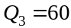, 75% of data lies below 60.
The answer is E.

Question 2

Option A is true.
Since 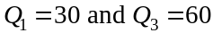, option B is true.
The median is 50 so half the calls were longer than 50 seconds and therefore more than half were longer than 40 seconds. Option C is true.
Option D is not true since half the calls were shorter than 50.
The answer is D.

Question 3

From the histogram, of employees worked between 8 and 12 hours during this week.
The answer is D.

Question 4

For the assignment,
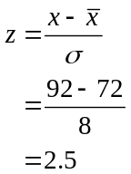
So, for the exam,
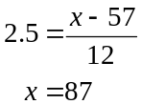
The student needs a score of 87 on the exam.
The answer is C.

Question 5
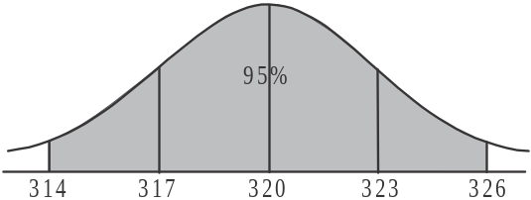
Draw a diagram.

We know that 95% of the weights lie between
314g and 326g; that is, between two standard
deviations either side of the mean.
Because of the symmetry of the normal curve,
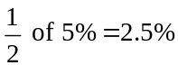 lie below 314g.
So .
The answer is A.

Question 6

Enter the data for the “after” BMI and using 1 – variable statistics on your calculator,

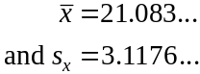
So, correct to one decimal place, the mean is 21.1 and the standard deviation is 3.1.
The answer is B.

Question 7

Enter the data for the before BMI and, using the data for the after BMI which was entered for question 6, calculate the equation of the least squares regression line. Be very careful referring to the correct list. The before variable is the independent variable (x-list) and the after variable is the dependent variable (y-list).
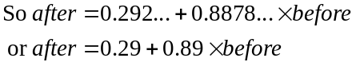
(correct to 2 decimal places)
The answer is E.

Question 8

Because the correlation coefficient between the number of staff working at the complex and ticket prices is positive, then any regression line will have a positive slope or gradient so option A is not true.
Option B is not true. The association between audience numbers and ticket prices is stronger. The negative sign indicates that as prices go up, audience numbers go down.
Option C is wrong since the correlation coefficient between the number of staff working at the complex and ticket prices is positive so as one increases so does the other.
Option D is true because the correlation coefficient between audience numbers and ticket prices is – 0.697, so as stated earlier, as ticket prices increase, audience numbers decrease.
Note that option E is wrong since
The answer is D.

Question 9

When number of weeks
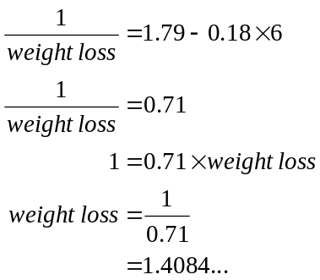
The closest answer is 1.4kg.
The answer is B.

Question 10

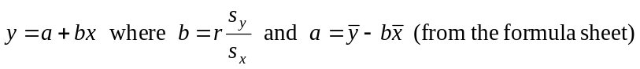
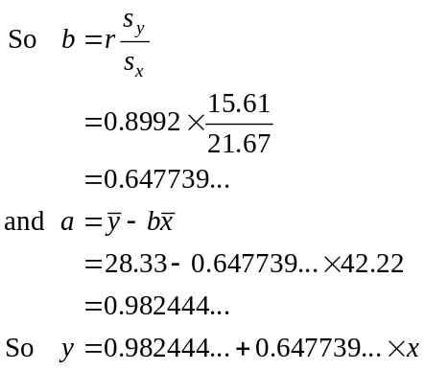

So our least squares regression line equation involving the variables length and weight is
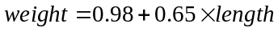, where a and b are expressed correct to 2 decimal places.
The answer is C.

Question 11

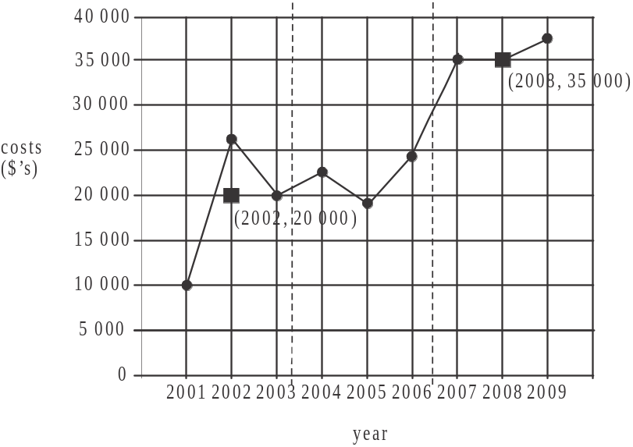

There are 9 pieces of data in total so when we divide the data into 3 regions there are 3 pieces of data in each region.
We need only find the medians in the outer two regions which are indicated by squares in the diagram above.
The gradient of the line joining these two ‘outer’ medians is given by
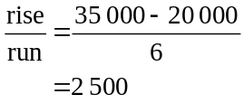
So the annual average increase in costs is $2500.
Note that to find the actual 3-median line we would need to find the median of the data in the middle region. For this question however, we only need the slope of the 3-median line which can be found using just the outer two medians.
The answer is C.

Question 12

Month | Number of day procedures | 4 – moving mean | 4 – moving mean with centring
June | 16
July | 9
 |  | 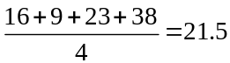
August | 23 |  | 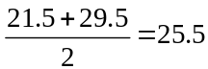
 |  | 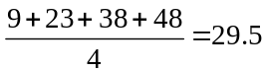
September | 38
October | 48
The answer is B.

Question 13

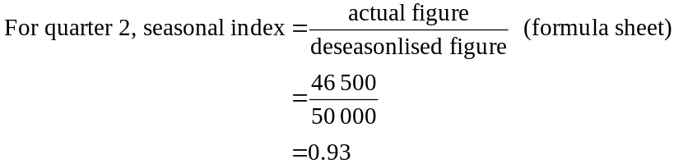
Since the four quarterly seasonal indices must add to give 4, and quarters 2, 3 and 4 add to give 2.8, the seasonal index for quarter 1 equals .
The answer is C.

SECTION B

Module 1: Number patterns

Question 1

For the arithmetic sequence, 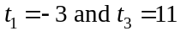.
So 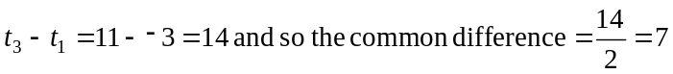
So 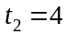.
The answer is B.

Question 2

For the sequence 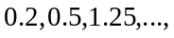
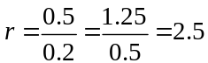
So
The answer is E.

Question 3

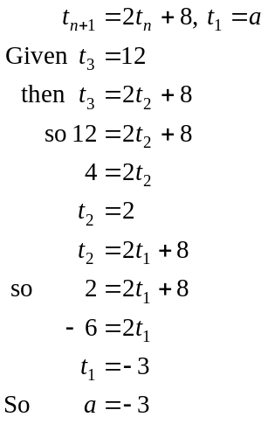
The answer is A.

Question 4

The sequence is not arithmetic since the difference equation is not of the form 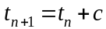.
The sequence is not constant since from Question 3, 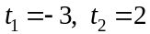 and so on.
The sequence is not geometric since the difference equation is not of the form 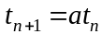.
The sequence is not Fibonacci related since the difference equation is not of the form 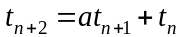.
The sequence is increasing.
The answer is D.

Question 5

The amount of sunscreen delivered by each pump forms a geometric sequence with , since each pump delivers 1% less than the previous pump.
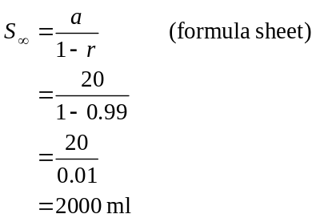
The answer is D.

Question 6

Generate the sequence on your calculator.
The sequence converges at 50.
The longest ride Tim will do will last for 50 minutes.
The answer is D.

Question 7

Since the first term is negative we eliminate option B.
Option A shows an arithmetic sequence so we can eliminate it.
Option D shows a sequence with a negative common ratio.
Option E is incorrect since if the first term is negative and the common ratio is positive then the sequence cannot have a positive term.
The answer is C.

Question 8

Use your calculator to generate the geometric sequence.
So the distance between the 7th and 8th hats is 17.71561 metres.
The distance between the first and the last hat is given by
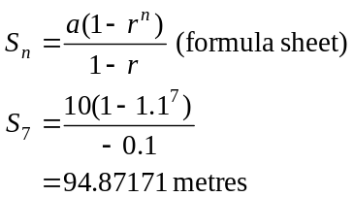
The answer is C.

Question 9
A difference equation can be created to reflect this situation.
Let 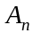 represent the amount of fuel in the tank at the start of the n^{th} week.
So,
Note that since 7% is sold each week, 93% remains in the tank.
Now generate this sequence on your calculator.
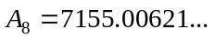
The closest answer is 7155.
The answer is E.
Module 2: Geometry and trigonometry

Question 1

Because we have a regular octagon,
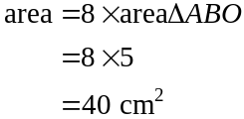
The answer is D.

Question 2

The area of 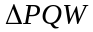
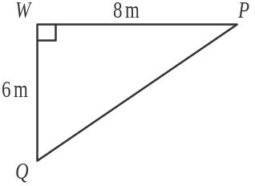
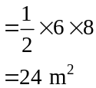
The area of rectangle 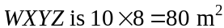.
The area of the shaded region
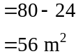
The answer is C.

Question 3

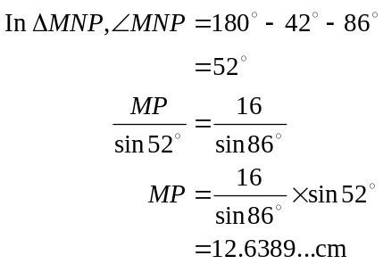
The closest answer is 12.64cm.
The answer is B.

Question 4

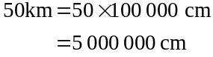
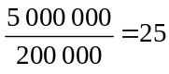
So on the map the distance between the two cities would be 25cm.
The answer is E.

Question 5

Point X lies on the 20m contour and point Y lies on the 40m contour so X is lower than Y. This eliminates option D.
The cross-section in options B and C rise too quickly.
Option E has two peaks whereas there should only be one.
The answer is A.

Question 6
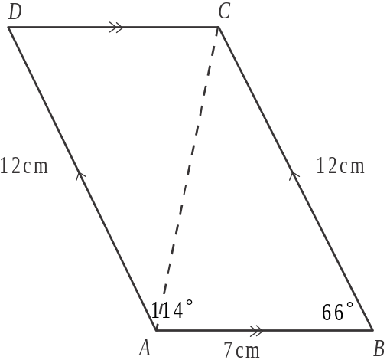

Find AC, the shorter diagonal.
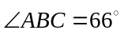 (cointerior angles add to give 180°)
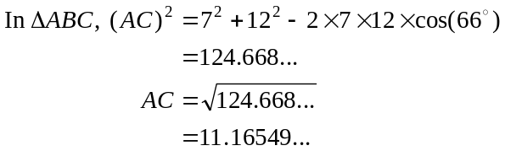
The closest answer is 11.2 cm.
The answer is C.

Question 7
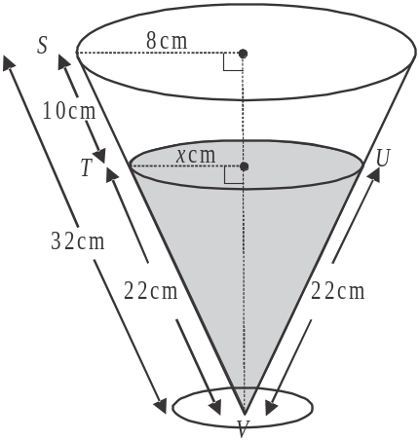

The slant height of the glass is 32 cm.
Using similar triangles,
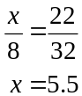
Now x represents the radius of the circular
surface area of the beer so
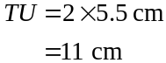
The answer is D.

Question 8

Draw a diagram.
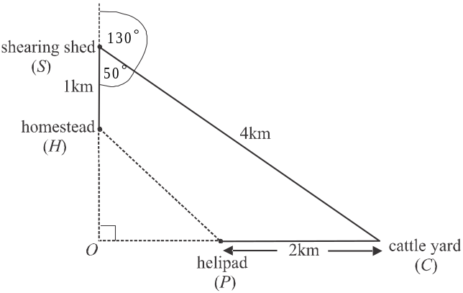

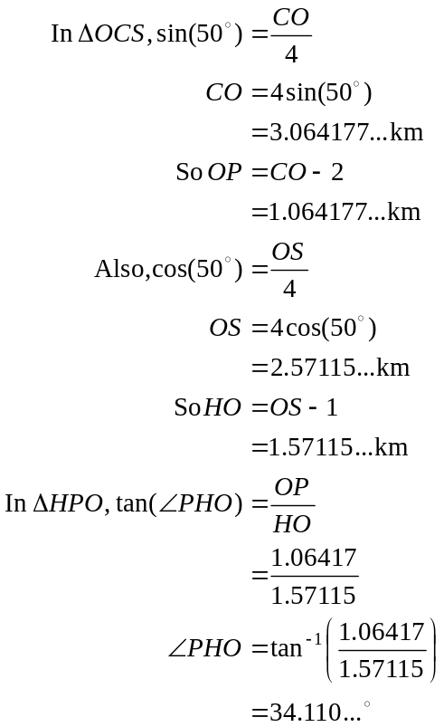
The bearing of the helipad from the homestead is equal to 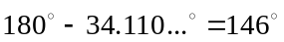 (to the nearest degree).
The answer is E.

Question 9

The volume of the container
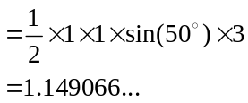
The volume of the grain in the skip where h is the height of the grain.
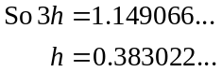
The closest height is 0.38m.
The answer is B.

Module 3: Graphs and relations

Question 1

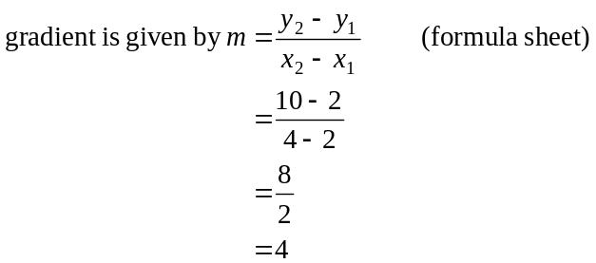
Equation of a straight line given by
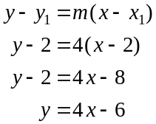
The answer is D.

Question 2

Method 1
Substitute each point into the inequality.
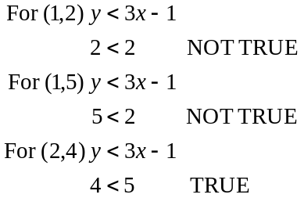
The answer is C.

Method 2
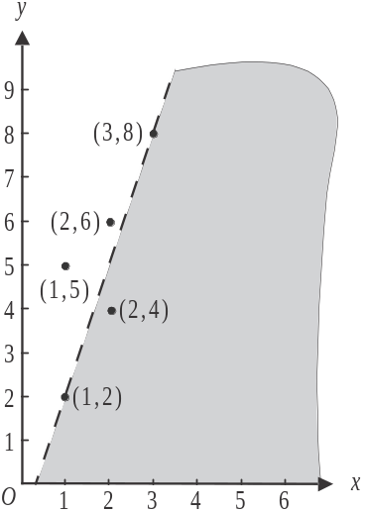
The shaded area represents 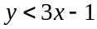.
Note that the boundary is not included
because we have a < sign rather than
a sign, so the points 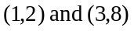,
which both lie on the boundary,
do not satisfy the inequality.
The only point that does is 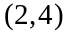.
All the other points lie above the shaded region.
The answer is C.

Question 3
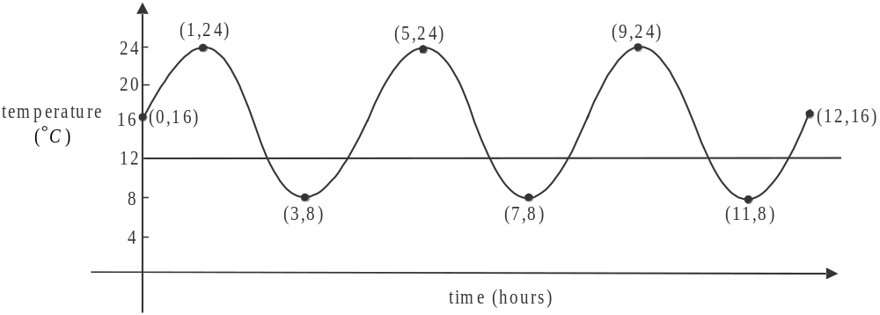

The horizontal line indicates when the temperature is 12°C.
This line crosses the graph 6 times.
The answer is D.

Question 4

For the first job,
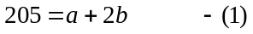
For the second job,
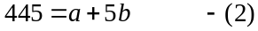
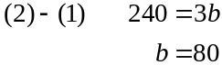
The answer is C.

Question 5

The horizontal line 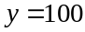 forms one border of the shaded region.
Since the area below this line is shaded, then the constraint 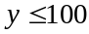 tells us that there can be no more than 100 large dogs at the kennel, since y represents the number of large dogs at the kennel.
The answer is E.

Question 6

Since the relationship between the variables A and is a straight line, we start by finding the gradient.
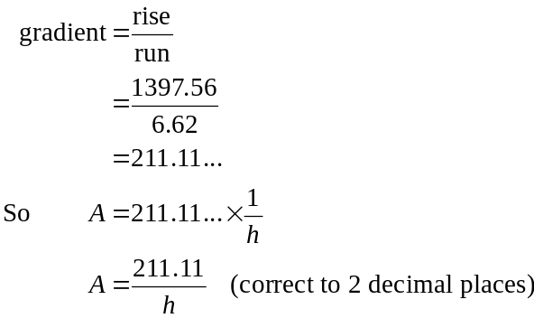
The answer is D.
Question 7

For every 1 tablet of supplement A taken, the athlete will get 2g of the substance and for every one tablet of supplement B taken, the athlete will get 5g of the substance. So the total amount of the substance the athlete gets is 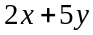; that is, it depends on how many tablets of each supplement he or she takes.
We want 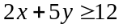, because the athlete wants to have a minimum of 12g of the substance each day.
The answer is A.

Question 8

The rule for Pat’s revenue is given by the hybrid function

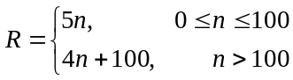

There are different rules for R depending on the value of n.
We know that break even occurs when .
Start by equating the first branch of the revenue function to the cost function and solve for n.
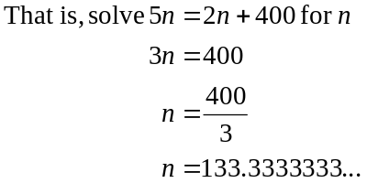
This is a problem because the rule we used for the revenue function i.e. only applies if so this answer is not feasible.
Now equate the second branch of the revenue function to the cost function and solve for n.
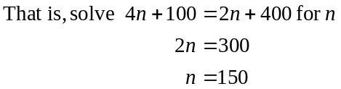
The rule we used this time for the revenue function was 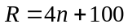 and this rule is defined for , so this time our answer is feasible. Break even occurs when Pat sells 150 pots of jam.
The answer is C.

Question 9

Since the maximum value of the objective function 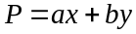 occurs at the points 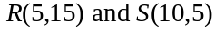,
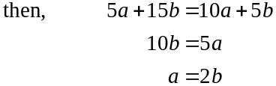
The only option which has the value of a twice that of the value of b is option B, where .
The answer is B.
Module 4: Business-related mathematics

Question 1

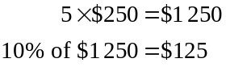
The total charge is 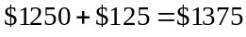
The answer is E.

Question 2

Over the three years, Rita made a total of 12 payments so .
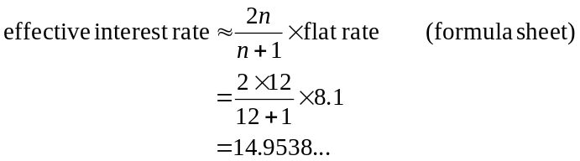
The closest answer is 15%.
The answer is B.

Question 3

The simple interest earned was 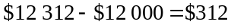.
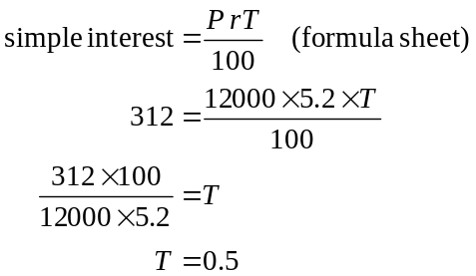
The answer is A.

Question 4

In 2010 the attendance was 98 500.
In 2011 the attendance was 10% less than this i.e. 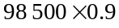.
In 2012 the attendance was 10% more than the 2011 attendance figure; that is, in 2012, the attendance was 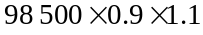.
The answer is E.

Question 5

Since annual turnover increased by 15% each year during this period, then
2011 annual turnover 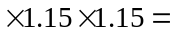$176 00
2011 annual turnover 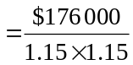
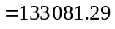
The closest answer is $133 081
The answer is C.

Question 6

The graph increases by the same amount ie $200 each year. This means that Sam earned simple interest of $200 each year on his investment.
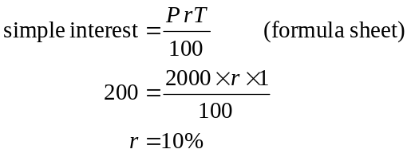
Therefore Jane will earn 10% simple interest on her investment over 12 years.
Again, using the simple interest formula from above,
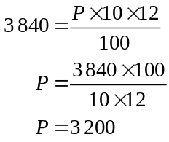
Jane’s original investment was $3 200.
The answer is C.

Question 7

Using TVM, we have

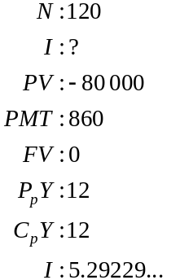
The closest answer is 5.3%.
The answer is D.

Question 8

Using TVM
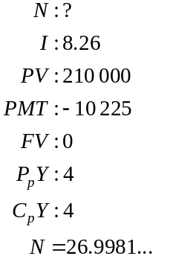
Option A is incorrect since it will take almost 27 quarters or 6.75 years to pay off the loan.
Again using TVM,
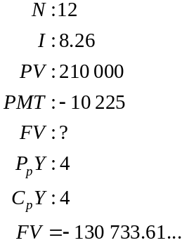
Option B is incorrect since after 3 years (or 12 quarters), Marita owes less than $135 000; that is, she owes $130 733.61.
Again using TVM,
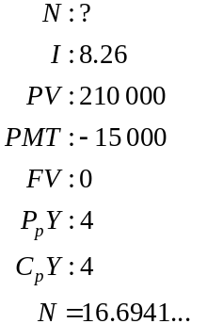
Option C is incorrect because if Marita’s repayments were $15 000 instead of $10 225, she would take 16.6941 quarters to fully pay out the loan. This is more than half 26.9981 quarters which it would take if she made quarterly repayments of $10 225 (using our working from option A).
The amount of interest in Marita’s first payment is given by
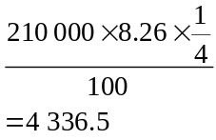
Since $4 336.50 is less than $4 500, option D is correct.
The answer is D.

Question 9

At the end of 2 years, the value of the investment is given by
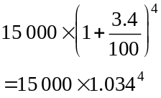
since the interest per six months is and there are 4 six month periods in 2 years.

Similarly, after 3 years, the value of the investment is given by
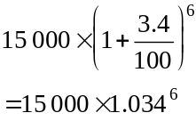
The interest earned on the investment during the third year is therefore given by 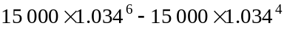
The answer is B.

Module 5: Network and decision mathematics

Question 1

A simple graph has no loops or multiple edges. Option C clearly has 2 loops so it is not simple. The multiple edges on options A, B and D are highlighted in bold below.
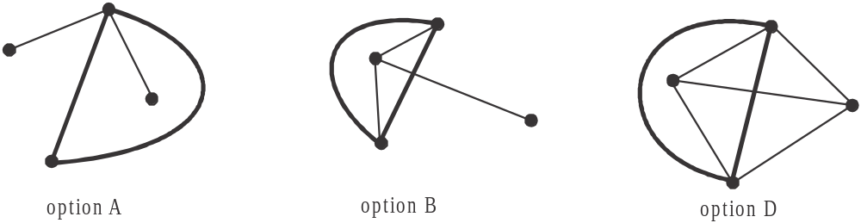

Option E has no loops or multiple edges.
The answer is E.

Question 2

Method 1
The graph has 9 vertices. A spanning tree is a subgraph that includes all the vertices of the original graph. Because it is a tree with 9 vertices it will have edges.
The answer is C.

Method 2
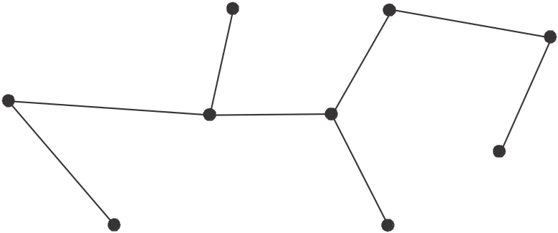

The spanning tree shown above is one of many that could be drawn. It has 8 edges. Note that each of the 9 vertices is connected.
The answer is C.

Question 3

Because the graph is planar, we can use Euler’s formula.
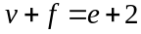 (formula sheet)
The graph has 6 vertices and 13 edges so,
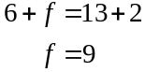
The answer is B.
Question 4

The graph has one loop at vertex C so on the leading diagonal of the matrix there should be a 1 in the C – C entry since vertex C is connected to itself via the loop.
This eliminates options C and D.
There are 2 edges joining vertices A and D so the A – D and D – A entries in the matrix should be 2. This eliminates option A.
There is an edge joining vertices A and C so the A – C and the C – A entries in the matrix should be 1. This eliminates option E.
The answer is B.

Question 5

Method 1
Using the Hungarian algorithm, take the time matrix given,
4 | 4 | 2 | 2
4 | 6 | 5 | 3
2 | 3 | 2 | 4
5 | 3 | 6 | 2

and subtract the minimum entry in each row from each other entry in that row.
2 | 2 | 0 | 0
1 | 3 | 2 | 0
0 | 1 | 0 | 2
3 | 1 | 4 | 0

Note that the second column does not contain a zero, so subtract the minimum entry in this column i.e. 1 from all the other entries in it.
2 | 1 | 0 | 0
1 | 2 | 2 | 0
0 | 0 | 0 | 2
3 | 0 | 4 | 0

Cover the zero entries with the minimum number of lines (horizontal and/or vertical).
2 | 1 | 0 | 0
1 | 2 | 2 | 0
0 | 0 | 0 | 2
3 | 0 | 4 | 0

The minimum number required is four so we can complete the allocation using a bipartite graph (or just by looking at the table).
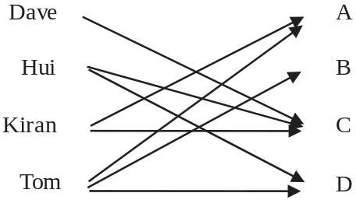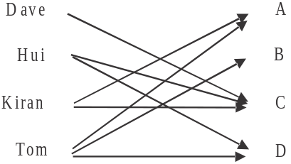

Dave can only do C. Hui can only do C or D so he gets D. Kiran can only do A or C so he gets A. Tom can do A, B or D so he gets B.
The minimum time taken is therefore
The answer is C.
Method 2 – trial and error
The fastest time for task A is 2 minutes.
The fastest time for task B is 3 minutes.
The fastest time for task C is 2 minutes.
The fastest time for task D is 2 minutes.
The fastest total time is 9 minutes BUT, the problem we have is that Tom is fastest in 3 of the tasks and Hui is not the fastest at any of the tasks. We bear this in mind given that each boy must be allocated one task.
For task A, Kiran and Tom are equal fastest taking 2 minutes.
For task B, Tom is fastest taking 3 minutes.
Try allocating Kiran to task A and Tom to task B. The total so far is 5 minutes and we have tasks C and D to allocate between Dave and Hui.
Dave can do task A in 2 minutes (same as Kiran but Kiran is already allocated) this leaves Hui to do task D which takes him 3 minutes (his fastest time). Even though Tom can do task D quicker (2 minutes) he has already been allocated to task B which he is quickest at. So by observation the fastest time with all the boys allocated a different task is .
The answer is C.

Question 6

If A to B is removed then we cannot reach any other vertex from vertex A.
Similarly, if D to C is removed then we cannot reach any other vertex from vertex D.
If C to G is removed then vertex G cannot be reached from vertex C or D.
If G to H is removed then vertex H cannot be reached by any other vertex.
If G to E is removed then this can be replaced by G to H to E.
The answer is D.

Question 7

Method 1 – using forward and backward passes.

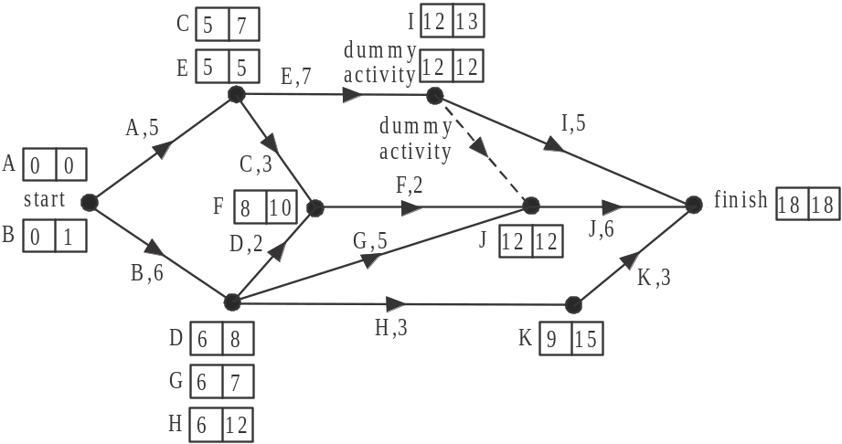

The critical path is A, E, J.
The answer is A.

Method 2 – inspection
Because of the limited number of ways from the start to the finish you can try each one.
A, E, I – 17 weeks
A, E, J – 18 weeks
A, C, F, J – 16 weeks
B, D, F, J – 16 weeks
B, G, J – 17 weeks
B, H, K – 12 weeks
The critical path is A, E, J.
The answer is A.

Question 8

From the graph, we know that:
Ari is taller than Matt and Harry.
Harry is taller than Matt.
Matt is taller than Ayce.
Ayce is taller than Jarrod.
From tallest to shortest, we have Ari, Harry, Matt, Ayce, Jarrod.
The third tallest cousin is Matt.
The answer is A.

Question 9

There are 4 different routes from W to N or N to W (which don’t go via E).
These are shown below.
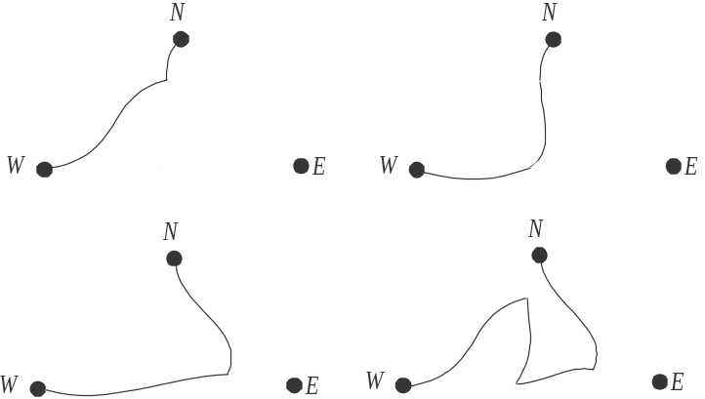

There are 2 different routes from N to E or E to N (which don’t go via W).
There are 2 different routes from W to E or E to W (which don’t go via N).
There is 1 loop from N to N (which doesn't go via E or W).
There is 1 loop from W to W (which doesn’t go via E or N).
Only option D shows these.
The answer is D.
Module 6: Matrices

Question 1

Method 1 – by hand
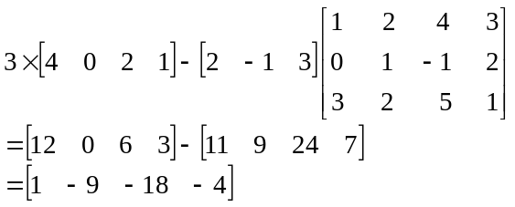
The answer is B.

Method 2 – using a calculator
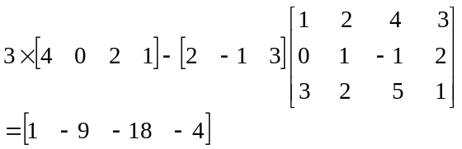
The answer is B.

Question 2

For the matrix product LC, L is a matrix and C is a matrix.
Since matrix L has two columns and matrix C has two rows the matrix product is defined.
The resulting matrix is of order (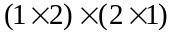 - the “outside” values give us the order of the resulting product).
This eliminates options A, C and E.
The total number of litres of fuel purchased is found by adding 63 and 42 so this eliminates option B.
The answer is D.

Question 3
The set of simultaneous equations can be written as
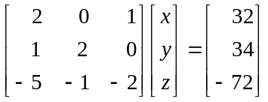
Pre-multiply both sides of the equation by the inverse of the matrix.
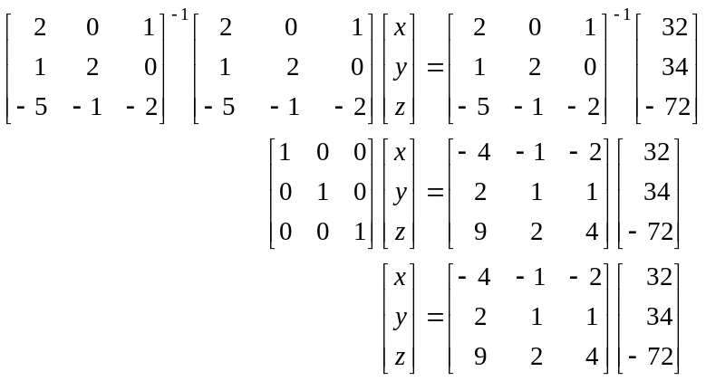
The inverse of the matrix can be found using your calculator.
The answer is E.
Question 4

The initial state matrix for day 1 is given by 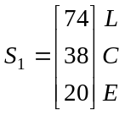
Now 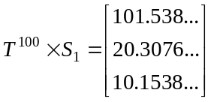
And 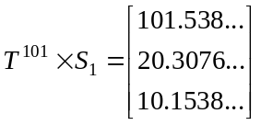
Since there is no change (at least for the number of decimal places shown) between one state and the next, a steady state has been reached.
Note that you can try any large number and subsequent number (eg. 50 and 51, 86 and 87 etc) to find the steady state.
The number of students in the long term spending their free classes in the common room is 20 (to the nearest whole number)
The answer is B.

Question 5

Matrices A and D have each of the vegetables as row entries and each of the siblings as column entries. This is how the table is presented. From the table, when expressed in this form the corresponding matrix should be
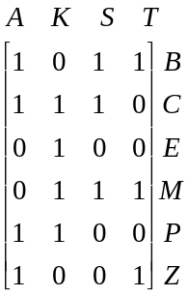
Neither options A or D give this so eliminate them.
Matrices B, C, and E have each of the siblings as row entries and each of the vegetables as column entries.
When expressed in this form the correct matrix should be
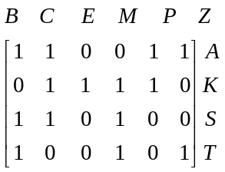
Only option E shows this.
The answer is E.

Question 6

The first entry of the column matrix is obtained by multiplying 40 by 0.8 because multiplying by 0.8 gives a 20% discount. The first row of the square matrix therefore should be

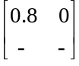
This eliminates options A, D and E.

The second row should be 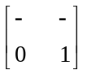 since the price of a top is unchanged. This eliminates option B.
Confirming this,
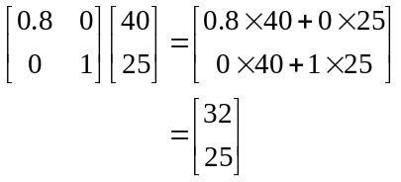
The answer is C.

Question 7

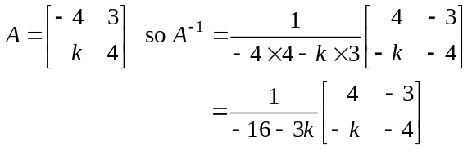
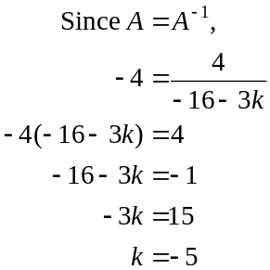
If you have time, double check with one of the other entries of the matrix, i.e.,
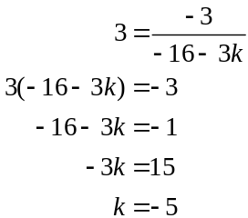
The answer is A.
Question 8

Doug is duty manager on Monday.
From the transition matrix, therefore, Clinton must be duty manager on Tuesday.
So Bhavani must be the duty manager on Wednesday and Emma must be the duty manager on Thursday. On Friday the duty manager is Doug again and the pattern of Doug, Clinton, Bhavani then Emma continues.
Therefore, options A, B, D and E are incorrect and option C is true.
The answer is C.

Question 9

Since 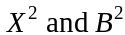 are defined then the matrices X and B must be square matrices. However, is not defined so X and B are not of the same order. For example if X is a matrix then B cannot be .
We’re also told that
Let’s let the order of X be and the order of B be .

Writing down the order of these two matrices gives us
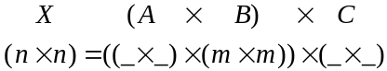

For the first product on the right hand side to be defined, the number of columns of matrix A must be m.
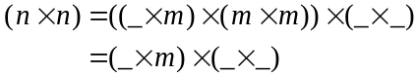

For the second product to be defined, the number of rows of matrix C must be m.
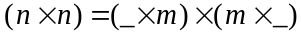

For this product to have n rows and n columns (as matrix X does), then the number of rows of matrix A must be n and the number of columns of matrix C must be n.

In summary, X is of order
A is of order
B is of order
C is of order
So 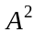 is not defined because A is not a square matrix.
is not defined because A and X are of a different order.
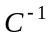 is not defined because C is not a square matrix.
BA is not defined because the number of columns of B is not equal to the number of rows of A.
CX is defined because the number of columns of C equals the number of rows of X.
The answer is E.

